**Simplilearn Phase Two Project**

**E-COMMERCE WEBSITE FOR SPORTY SHOES.**

**Core Concepts: Technologies used**

Language used – java

Framework- spring core, Hibernate, JSP

Database used MySQL,H2 Database

Tools Used: Eclipse , Spring, Mysql

**Database and Tables**

* jdbc:h2:mem:testdb
* Category – list of shoe categories
* User- list of users available
* Product- list of available shoe products
* Purchases – list of purchases encountered

**Screenshots:**

**Login Page:**

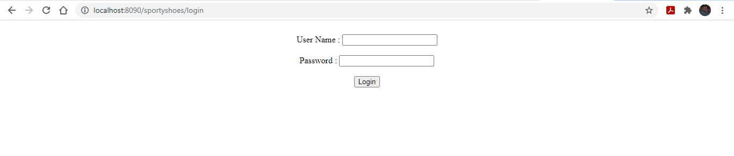

**Welcome Screen:**

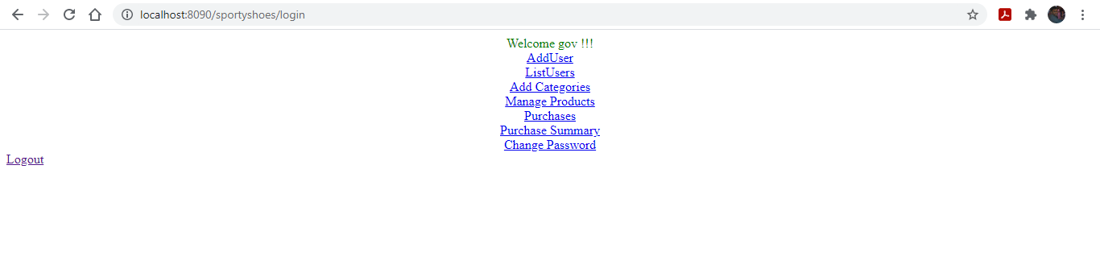

* **Adding user:**

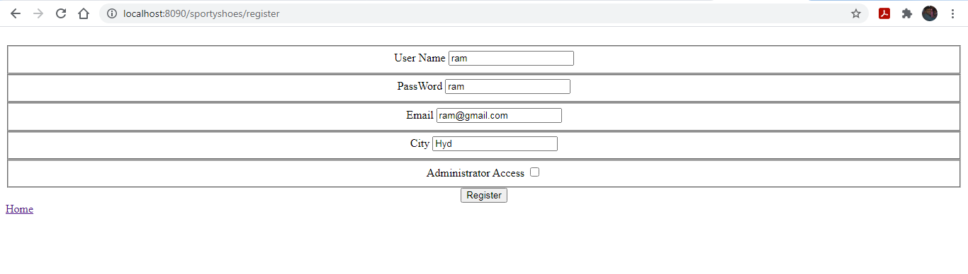

**Change Password:**

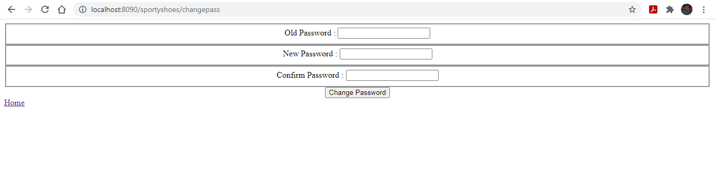

**Categories Page:**

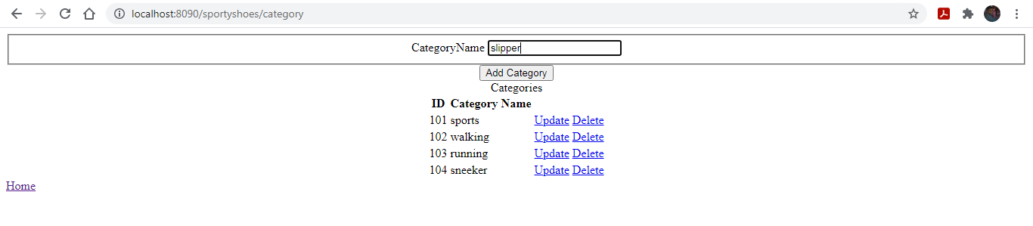

* **Adding slipper category**

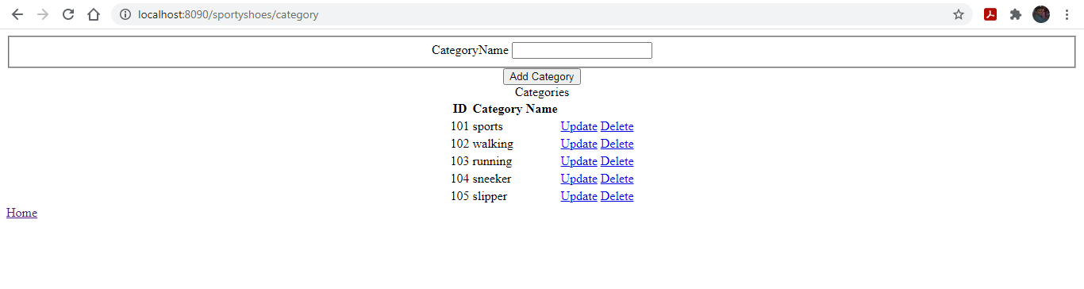

**Manage Products:**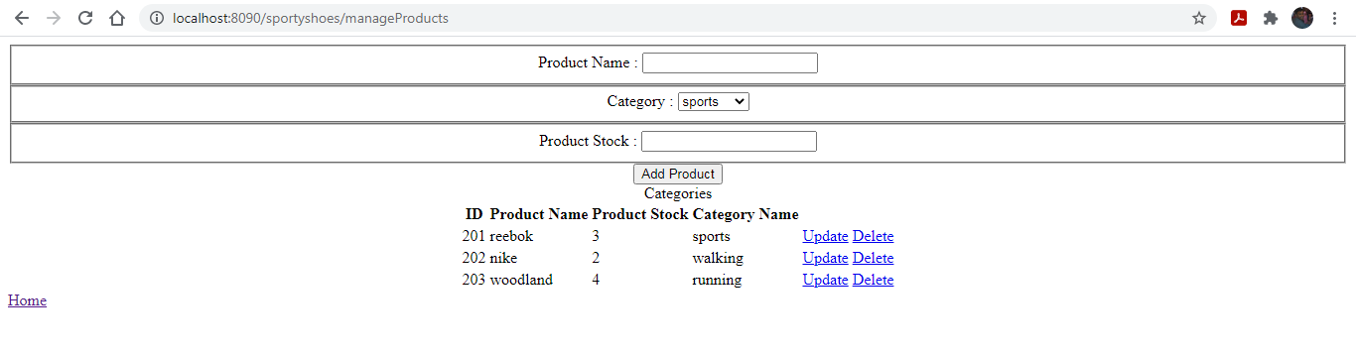

**View Purchase History:**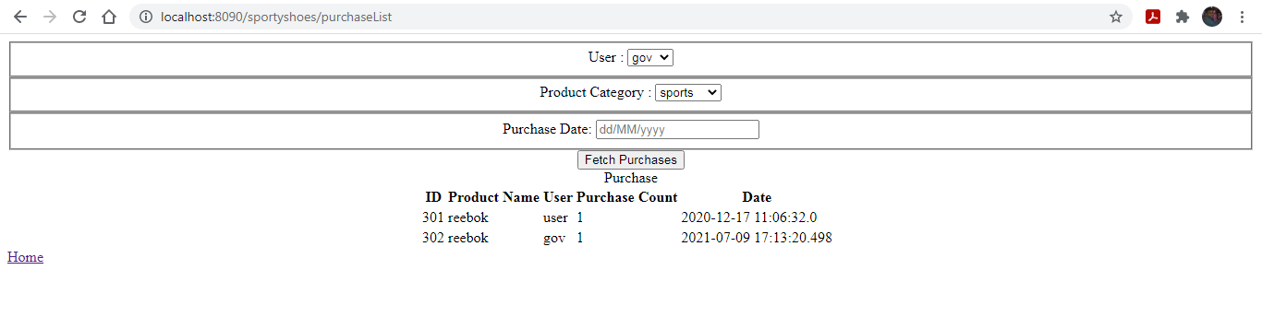

**H2 Database records:**

**Category:**

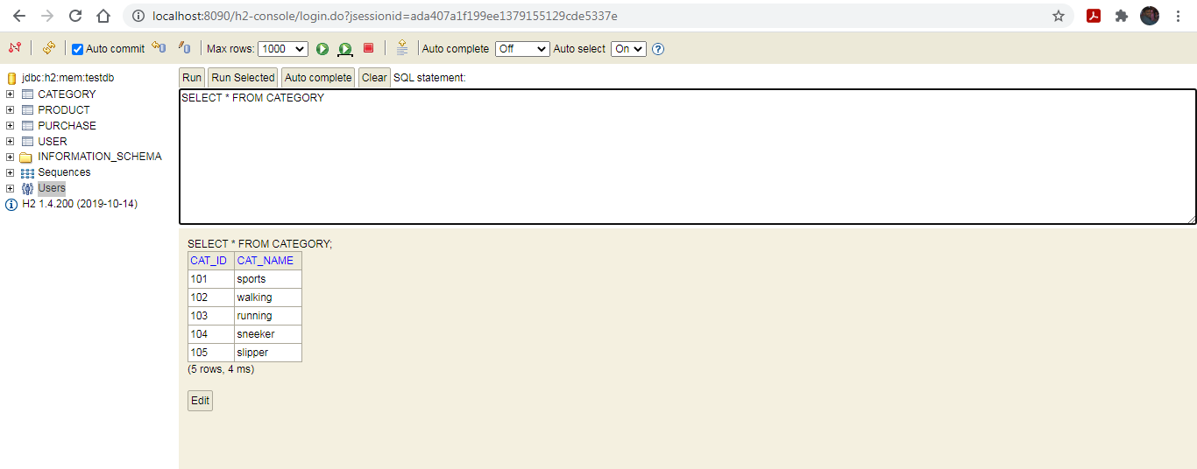

**Product:**

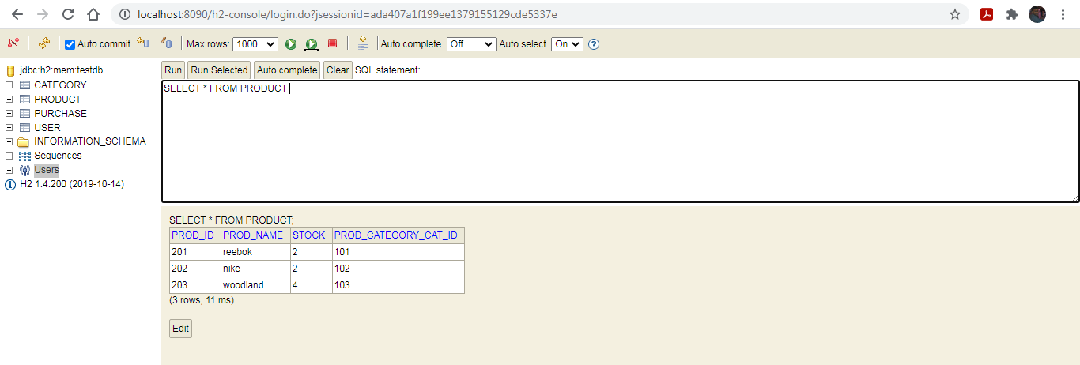

**Purchase:**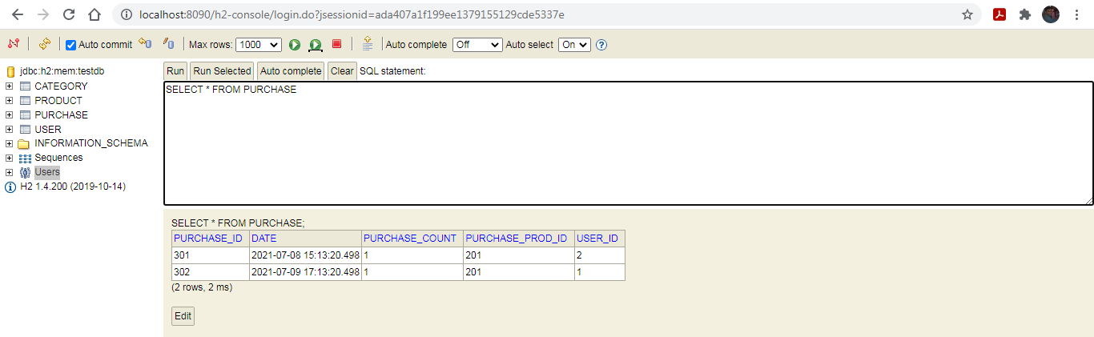

**User:**